Train yolov5 for fire dataset

**Train YOLOv5 On A Custom Dataset For Fire And Smoke Detection**

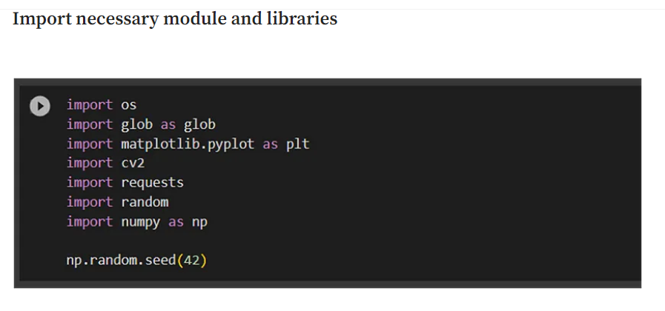

# Complete code in Google colab

<https://colab.research.google.com/drive/1-yKF77NrmpK_S_Xz12DjNOJs2wLKCvSC?source=post_page-----6d90fc98a354--------------------------------#scrollTo=otPcAibIIZNe>





